The C compiler which has been used is **gcc 4.1.1**

Compile the files using the following commands –

* gcc –g –o STAGE1 stage1.c –lgen
* gcc –g –o STAGE2 stage2.c -lgen
* gcc –g –o STAGE3 stage3.c –lgen

Screenshot is as follows-

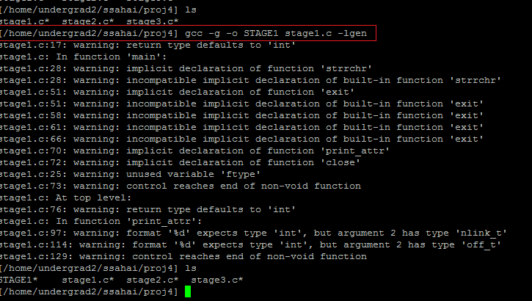

After compiling all the 3 files, your directory will look like the following



Output of the first Stage-

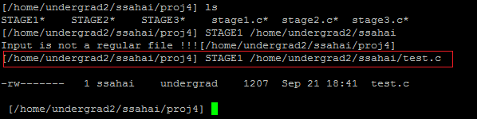

Output of second Stage-

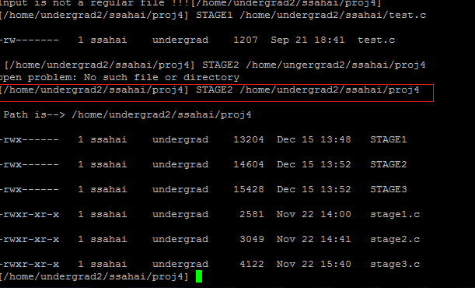

Output of Third Stage –

